LOAD N GO BERTH REGISTRATION FORM
The Manager grants to the Customer, and the Customer takes on the use of the Load N Go Berth at the Z Pier, Westhaven Marina for the purpose of berthing the Vessel listed
in this Application to load or unload passengers; complying with the attached Terms and Conditions and the A – Z Guide to Westhaven Marina.

CUSTOMER DETAILS
Name | Full Name:
 |  | AS SHOWN ON GOVERNMENT ISSUED IDENTIFICATION AND IF APPLICABLE, FULL NAME OF TRUST INCLUDING TRUSTEES
 | Company Name: |  |  |  |  |  |  |  |  |  |  |  |  |  |  |  |  |  |  |  | Company No. No.:
 |  | IF APPLICABLE
Physical Address | Street: |  |  |  |  |  |  |  |  |  |  |  |  |  |  |  |  |  |  |  | Suburb:
REGISTERED OFFICE FOR COMPANY
 | City: |  |  |  |  |  |  |  |  |  |  |  |  |  | Postcode: |  |  |  |  |  | Country:
Phone and Email | Home: |  |  |  |  |  |  |  |  |  |  |  |  |  |  |  |  | Work:
 | Mobile: |  |  |  |  |  |  |  |  |  |  |  |  |  |  |  |  | E-mail:
Emergency Contact | Name: |  |  |  |  |  |  |  |  |  |  |  |  |  |  |  |  | Number:
Guarantor | Mandatory where the Customer is not a natural person. If applicable, see clause 21 of the Load N Go Terms and Conditions
 | Full Name:
 |  | AS SHOWN ON GOVERNMENT ISSUED IDENTIFICATION
 | Address:
VESSEL DETAILS
Vessel Name |  |  |  |  |  |  |  |  |  |  | Vessel MNZ Number
Dimensions | Extreme Length: |  |  |  |  |  | Beam: |  |  |  |  |  |  |  |  |  |  |  | Draft: |  |  |  |  |  |  | Weight:
Colour | Deck: |  |  |  | Hull/Topsides: |  |  |  |  |  |  |  |  |  |  |  |  |  |  |  |  | Bottom:
Is the Vessel equipped with holding tanks? |  |  |  | Yes |  |  |  |  | No
INSURANCE DETAILS
The Customer acknowledges and agrees that it is a condition of the Agreement that the Customer holds protection and indemnity insurance cover of at least NZD$5,000,000 (to cover any third party loss caused by the Customer or the Vessel) prior to its arrival at Westhaven Marina and maintains the same during the term of the Agreement. To this end, the Customer undertakes to provide the Manager with a copy of a ‘Certificate of Currency of Insurance’ for the Vessel prior to the arrival of the Vessel at Westhaven Marina and on renewal of such insurance. The Customer also acknowledges that the Manager recommends that the Customer effect and maintain marine hull insurance (to cover loss or damage to the Vessel).
Initial
In addition to the above, the Customer consents to the Manager directly making enquiries with the insurer of the Vessel on the Customer’s behalf for updates as to the currency of the Customer’s insurance policy while the Vessel is berthed at the Marina.
Insurance Company |  |  |  |  |  |  |  |  |  |  |  | Policy Holder Name
Policy Number |  |  |  |  |  |  |  |  |  |  |  | Expiry Date
LOAD N GO FEE

The Load N Go Fee shall be $50.00 per half hour booking slot (including GST and outgoings)

Note: Fees and utility charges are subject to change by the Manager from time to time.

Please refer to the attached Terms and Conditions for conditions of payment.
TERM
Commencement Date upon signing by all parties |  |  |  |  |  |  |  |  |  |  |  |  |  |  |  |  |  |  |  |  |  |  |  |  |  |  |  |  |  |  | Asddsfdsfdsfdsfdsfdsxc  Cx’

Termination Date upon signing by all parties

CREDIT CARD DETAILS – I agree to enter my credit card details on through the Westhaven Website for Automatic deduction on the last day of the Month

EXECUTION
I/we acknowledge that I/we have read the terms and conditions of the Agreement and accept the same.
Signed for and on behalf of the Customer: |  |  |  |  |  |  |  |  |  |  |  |  |  |  |  |  |  |  |  |  | Date:
Signed by the Guarantor (if applicable): |  |  |  |  |  |  |  |  |  |  |  |  |  |  |  |  |  |  |  |  | Date:
Signed for and on behalf of the Manager: |  |  |  |  |  |  |  |  |  |  |  |  |  |  |  |  |  |  |  |  | Date:
OFFICE USE ONLY
Token ID:
Insurance Documents checked and saved Health and Safety Plan checked and saved
Identification verification checked and saved Credit Card Token Set up


Vessel length includes ALL appendages,
attachments and overhangs.

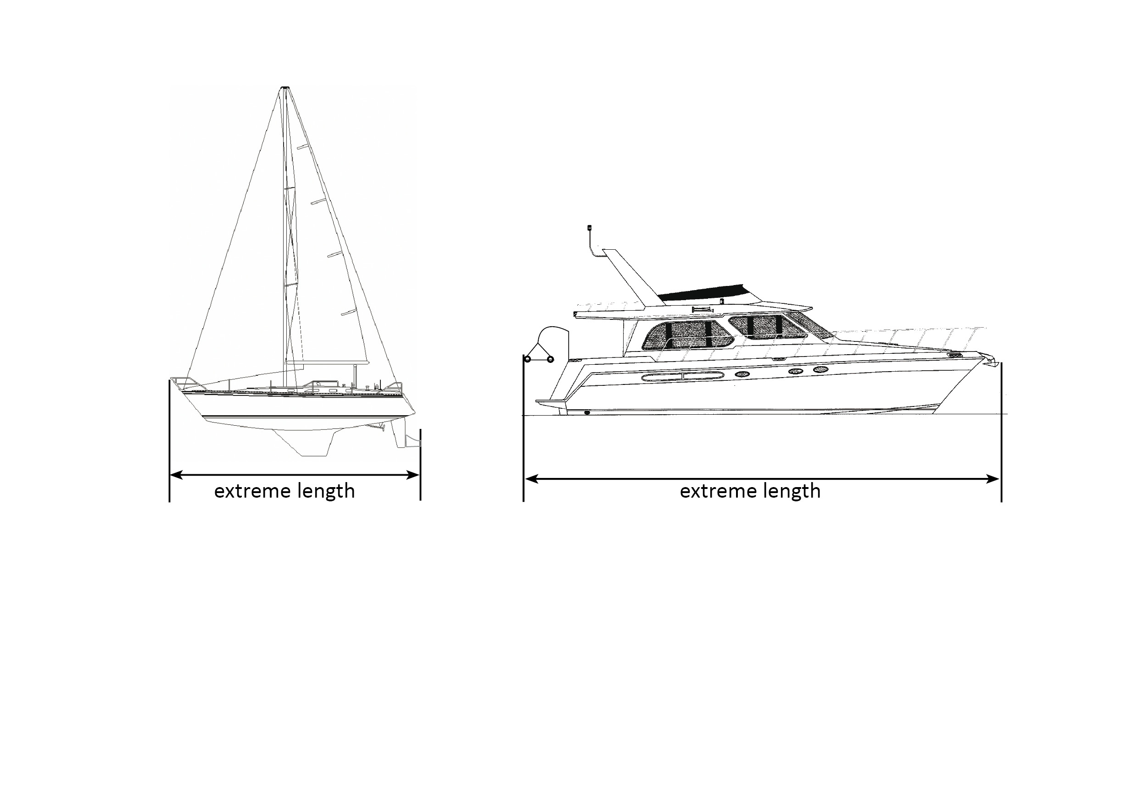
LOAD N GO
BERTH USE
AGREEMENT

